IS1 Project Report

Dipayan Sarker (disa2777@student.su.se), Johan Olausson (jool5820@student.su.se), Nishant Chahar(nich7346@student.su.se), Nicole Issa (niis8974@student.su.se), Peilin Li (peli9693@student.su.se)

October 31, 2021

Contents

**1 Introduction** **2**

**2 Value Network Analysis** **3**

2.1 VDML Diagram 3

2.2 VDML Diagram Explained 3

**3 Goal Design** **5**

3.1 Goal Model 5

3.2 Goal Model Explained 5

**4 Process Design** **6**

4.1 Exchange and Conversion Processes in REA 6

4.2 Detailed Processes in EPC 14

4.3 Relationships between Models 18

**5 IT Architecture Design** **19**

**6 Business Performance Management** **20**

6.1 Leading and Lagging KPIs 20

6.2 Evaluation of KPIs 22

**7 Enterprise Architecture Evaluation** **22**

**Capability Elicitation** **23**

# 

# 1 Introduction

This section is to give a general introduction to the company, including a description of its main product offerings, markets and strategy.

1.1 MMORPG (Massively Multiplayer Online Role-Playing Game)

Massively Multiplayer Online Role-Playing Games or MMORPGs are video games played throughout the entire world. It combines the aspects of a role-playing video game and a massively multiplayer online game. What distinguishes MMORPGs from single-player or small multiplayer online RPGs (role-playing games) is the number of players able to interact in the game and the world in which the game takes place, which continues to evolve even when the player is offline.

Some basic characteristics of MMORPGs include common features such as persistent game environment, level and character progression, social interaction within the game, in-game culture, system architecture, membership in a group, and character customization. The virtual world of MMORPGs is most often based on traditional fantasy themes and in nearly all cases the development of the player’s character is the primary goal. The progression of the player’s character is most often based on earned experience points which are used to reach new character levels. The most used server software for the deployment of MMORPGs is a client-server system architecture since it generates a persistent instance of the virtual world being run continuously [1].

1.2 SU Interactive

SU Interactive is a start-up company producing and selling an MMORPG. The company will primarily sell the game to customers. Customers can choose to buy the game through CD’s or through a monthly subscription to be able to play the game over the internet. The game will be distributed and sold at computer game retailers. Additionally, the game will be sold through Google Stadia.

SU Interactive has signed agreements with several ISPs which states that the ISP can include the game for free for its subscribers.

Furthermore, SU Interactive intends to cooperate with several third-party suppliers. These suppliers, which must be authorized to be able to sell in-game equipment to players, e.g., armour, weapons, buildings, or land areas. The in-game equipment can be produced by a third-party supplier, or it can be bought from SU Interactive or players. For each transaction carried out, SU Interactive intends to take a small fee.

Most of the in-game equipment being sold from SU Interactive directly to players is on the shelf, meaning that the equipment is pre-existing. SU Interactive offers the possibility to get specially tailored equipment. In this case, SU Interactive will collaborate with the player on designing the equipment before the player decides to buy it.

SU Interactive is also sponsoring the Game Forum, which is a company established by famous gamers and intends on gathering innovative design ideas from players all around the world. These innovative ideas will be utilized by SU Interactive to develop the MMORPG game further. The players that contribute with the best ideas will be rewarded with money from the Game Forum. The Game forum is also an important marketing channel that will get revenues from advertisements on its website.

SU Interactive also has agreements with an IT-Service provider and a Data Mining firm. The IT-Service provider will help SU Interactive in the maintenance of the game by providing IT resources and services that are required. The Data Mining firm will provide SU Interactive with relevant player data in order to find trends within the player base.

# 2 Value Network Analysis

This section is to show the value network in which the company will work. Agents, resources, and exchanges of resources are to be made explicit. Note that the project group here has to clarify exactly which products the company is to offer. Also, note that the value network analysis has to take into account that the company is to work in different markets with different actors.

## 2.1 VDML Diagram

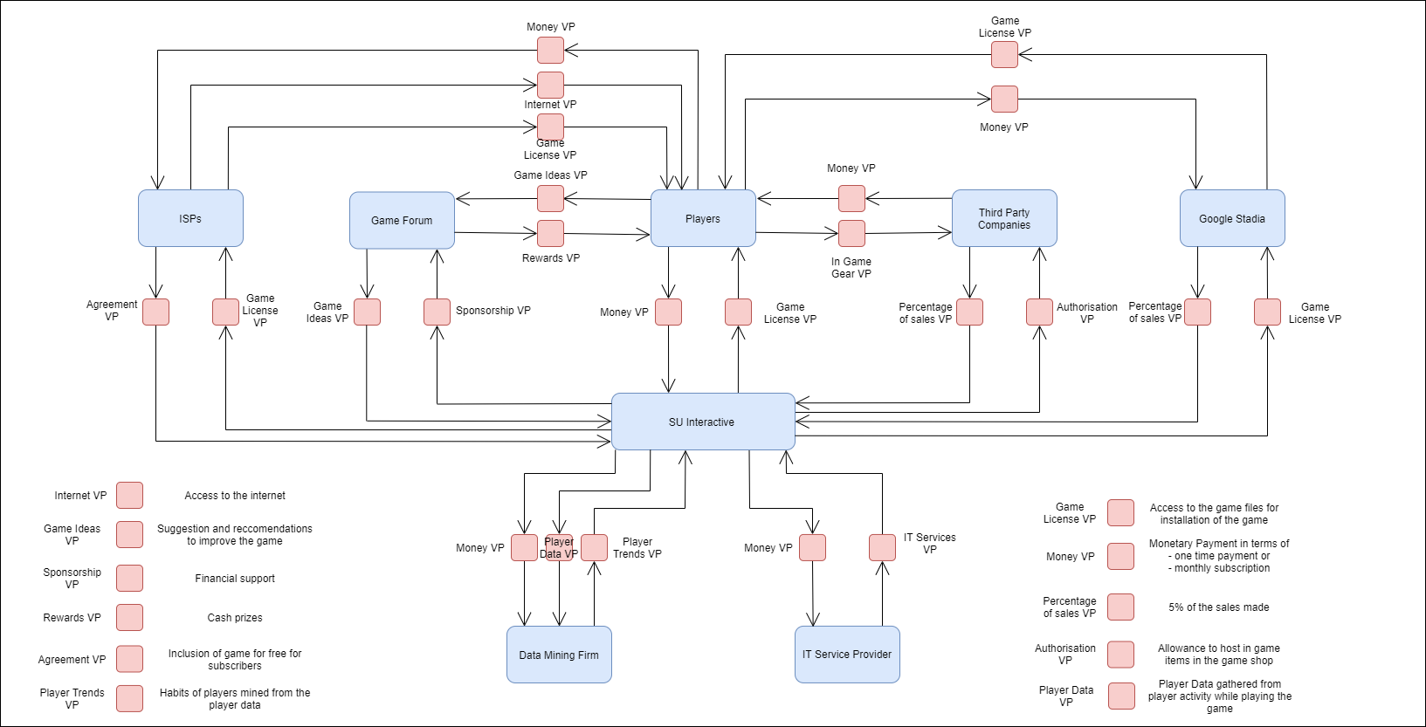

Figure 1. VDML Diagram of SU Interactive

## 2.2 VDML Diagram Explained

According to the Object Management Group, “The purpose of VDML is to provide a standard modelling language for analysis and design of the operation of an enterprise with particular focus on the creation and exchange of value.” **Figure 1** shows the VDML Diagram which consists of Economic Agents and their Value Proposition with each other. Below are the descriptions of each of those things.

**Economic Agents**

1. **SU Interactive:** The Game Studio developing and producing the MMORPG game.
2. **ISPs:** The Internet Service Providers act as distributors of the game by providing it for free when a user subscribes to them.
3. **Game Forum:** An online open forum for players to provide feedback for the game as well as see their competitive standings.
4. **Players:** People that are buying and subscribing to the game to play.
5. **Third Party Companies:** Companies that apply to sell in-game gear to players.
6. **Google Stadia:** A cloud service developed by Google that provides cloud gaming for its subscribers.
7. **Data Mining Firm:** A company that analyses the Player Data from the game to find trends within the playerbase.
8. **IT Service Provider:** The provider of all the IT Resources and Services required to run and maintain the game.

**Value Propositions**

1. **ISPs - SU Interactive**
   1. **Game License VP -** License of the game for ISP to provide it to its subscriber
   2. **Agreement VP -** ISPs agreement to provide our game free of cost to its subscriber
2. **ISPs - Players**
   1. **Money VP -** Payment paid by the players to the ISP in form of a subscription
   2. **Internet VP -** Internet service provided by ISP to the players
   3. **Game License VP -** License of the game made available to subscribers of the ISP
3. **Game Forum - SU Interactive**
   1. **Game Ideas VP -** Innovative ideas provided by players to improve the game
   2. **Sponsorship VP -** Support from the SU Interactive to Game Forum
4. **Game Forum - Players**
   1. **Game Ideas VP -** Suggestions and recommendations to improve the game
   2. **Rewards VP -** Cash Prize for the player with the most upvoted recommendation
5. **Players - SU Interactive**
   1. **Money VP -** Payment/Subscription paid by the players to play the game
   2. **Game License VP -** License of the game provided to the players
6. **Third-Party Companies - SU Interactive**
   1. **Percentage of Sales VP -** A cut of sale on every sale made on their product
   2. **Authorisation VP -** An authorization for 3PC to open their stores in-game
7. **Third-Party Companies - Players** 
   1. **Money VP -** Payment paid to buy in-game gear
   2. **In-Game Gear VP -** Digital items that can be bought in-game
8. **Google Stadia - SU Interactive**
   1. **Percentage of Sales VP -** A cut of sale on every game sale made through Stadia
   2. **Game License VP -** License of the game for Stadia to provide the buyers
9. **Google Stadia - Players**
   1. **Money VP -** Payment/Subscription paid by the players to play the game
   2. **Game License VP -** License of the game provided to the players
10. **Data Mining Firm - SU Interactive**
    1. **Money VP -** Payment provided for the data mining services
    2. **Player Data VP -** RawPlayer Data generated from the game
    3. **Player Trends VP -** Trends generated after mining the raw data
11. **IT Service Provider - SU Interactive**
    1. **Money VP -** Payment provided for the IT resources and services
    2. **IT Services VP -** IT services and resources provided to run and maintain the game

**Economic Resources**

1. Game License
2. Money
3. Player Data
4. IT Services
5. Game Ideas
6. Commission
7. Authorisation
8. In-Game Gear
9. Agreement

# 3 Goal Design

This section is to show the goals of the company. We have taken significant influence from the five forces model and made sure to relate our goal model to it. All of our goals have been developed with the five forces model in mind. Please see the textual description of the BMM below.

## 3.1 Goal Model

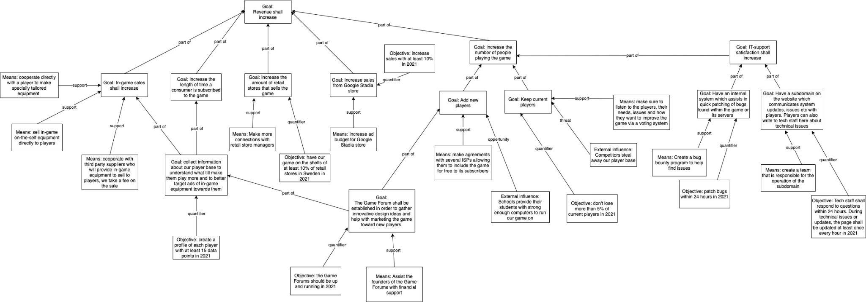

Figure 2. Goal Model Diagram of SU Interactive

## 3.2 Goal Model Explained

**The Threat of new entrants and entry barriers** will be handled with the **Goal: In-game sales shall increase** as it makes the playering financially invested in our game and less likely to stop playing as they cannot real world trade the in-game items. So all of their in-game items are essentially lost if they stop playing. This binds our players to us and makes it difficult for new entrants to take our player base thus creating an entry barrier for competitors. We will be collecting data on the players via the game forum to gain insight of individual player interest which allow us to better target ads of in-game equipment. This will be done with **Goal: collect information about our player base to understand what will make them play more and to better target ads of in-game equipment towards them**. Another goal reinforces this lock-in effect, **Goal: Increase the length of time a consumer is subscribed to the game** since for every hour a player spends making progress in our game they become more invested in it. By increasing the player's cost to switch games we are effectively increasing our **Supplier power** and achieving **the Goal: Keep current players.** To further reinforce this, we have also developed the goals **Increasing the number of retail stores that sell the game** and **Increasing sales from the Google Stadia store.**

SU Interactive aims to tackle the **Threat of Substitution** by continuously developing our game to stand out in a unique way from potential substitute games, we will do this by listening to our players with **Goal: The Game Forum shall be established in order to gather innovative design ideas and help with marketing the game toward new players.** The **Threat of Substitution** is additionally tackled by making our players both more financially and time invested in our game. Since they cannot transfer this progress to a substitute game they will lessen the degree to which they see other similar games as substitutes by every hour spent playing our game. We will also tackle the **Threat of Substitution** by making our game price competitive and even by partnering with ISP providers who will be able to offer our game for free to their customers. Our agreements with ISPs will give us a price advantage over our competitors. The **Buyer power** is weakened since the players will be increasingly bound to our game by both the financial and time invested in our game. But we are also increasing the **Buyer power** by allowing the player to group together and assemble on the game forums which will give them significant influence over the game. We see player influence as a positive since it will ensure that the game is developed in a way that pleases the players and thus they spend more time playing and becoming more invested in it. We also aim to increase **IT-Support satisfaction** by utilizing player feedback as it is key to our overarching goal of increasing our player base which in turn will increase revenue and profits.

# 4 Process Design

This section is to show the processes of the company. The processes shall be clearly related to the value network analysis in Section 2 and the goal design in Section 3.

## 4.1 Exchange and Conversion Processes in REA

The value of company resources can be increased or decreased by exchanges or by conversions:

* Exchange is a process in which a business obtains economic resources from other businesses and distributes those resources to other businesses in exchange.
* Conversion is the process through which a company uses or consumes resources to create new resources or modify existing ones.

The application designers can define the relevant concepts through REA interactive models. The idea behind the REA models is that our SU interactive (the enterprise) is increasing the total value of the resources under our control, while other valuable resources are being decreased.

Our REA exchange processes are listed here and categorised with different type processes:

1. Outsourcing

1.1 SU Interactive and Data Mining Firm

1. Subscription

2.1 ISPs and Players

2.2 SU interactive and IT Service Provider

1. Feedback source

3.1 Game Forum and Players

1. Order

4.1 SU Interactive and Third Party Companies

4.2 SU Interactive and Players

4.3 Third-Party Companies and Players

1. Investment

5.1 SU Interactive and Game Forum

1. Agreement

6.1 SU Interactive and ISPs

From above categorised REA processes, we can see that there are in total six different exchange processes between each model related to the company. In the REA application models listed and explained below, our REA models’ exchange dualities are presented so that every increment of economic event is related by an exchange of decrement economic event, and vice versa.

| REA processes and textual explanations |
| --- |
|  |
| For example in our REA models (REA Model figure 3) regarding outsourcing between Data Mining Firm and SU interactive, who has given the data to data mining firm. This is called an exchange process, where the data is seen as a collection of certain rights associated with it such as ownership rights, usage rights and copyrights. In this case, it is the right to data insights of the players. |
|  |
| Subscription exchange process between SU interactive and IT Service Provider (Figure 4).  The exchange process is where an IT service provider takes access to IT resources and Services where SU interactive pays for it with money. |
|  |
| Order exchange process between SU Interactive and Third Party Companies (Figure 5). The exchange process is where SU Interactive provides Game forum in-game store (authorisation) and SU interactive gets commissions based on the percentage of sales. |
|  |
| Investment exchange process between SU interactive and Game Forum (Figure 6) where SU interactive invests funding (money) to Game Forums in order to receive feedback (game ideas). |
|  |
| Agreement exchange process between SU interactive and ISPs(Figure 7), where SU interactive grants the access or shipment of game product keys and discs (game license) to ISPs. SU Interactive gets the payments or the promise of payment (LCs) for the agreement. |
|  |
| Order exchange process between SU Interactive and Players (Figure 8), where SU interactive gives the access of game products keys and docs (game license) to the players. SU Interactive receives payments (money). |
|  |
| Agreement exchange process between SU Interactive and Google Stadia (Figure 9), where SU Interactive exchanges the access of game products keys and docs (game license) for percentage on sales (commission) with Google Stadia. |

## 

## 4.2 Detailed Processes in EPC

Include a number of detailed process models, expressed as EPC diagrams. The processes should include sales and procurement. The process models should show the actions of individual actors and handle alternatives and exceptions. It is recommended to make each process diagram small by using the decomposition mechanisms of EPC diagrams.

| **EPC Diagrams and Textual Explanations** | |
| --- | --- |
|  | The EPC process between SU Interactive and Players is shown in this accompanying figure. The process starts after the company receives the request for ‘game access’. Afterwards, we check the request and hence we arrive at the event of ‘request confirmed’. Next, we check if we can honor the request by performing ‘check request availability’ where an XOR decision is made. If the game access is unavailable, then we simply deny the access and end the process. On the other hand, if access is available then we approve the access and move forward with processing the access. In this stage, we pack the game equipment and send the order to the accurate players. |
|  | The figure describes the EPC process between Data Mining Firm and SU Interactive. The process initiates when data has been collected by the SU Interactive. Then data is sent to the mining company where they analyze the data and send us the ‘analyzed result’. At this stage, SU Interactive performs the quality check and thus arrives at the ‘quality checked’ event. Afterwards, a decision is made based on the quality of the analyzed result. If the resulting data is relevant then we accept it and send the payment to the mining firm; however, if the analyzed data is deficient then they are sent back to the data mining firm and the whole process is performed again until the analyzed data is satisfactory. |
|  | The figure illustrates the process of EPC between Game Forum and SU Interactive. The process begins with the receiving of feedback from the Game Forum. Then SU interactive checks and validates the feedback and thus it results in ‘validity of feedback checked’ event. Afterwards, the company performs a function of decision making whether the received feedback is relevant for the improvement of the game development. If they are justified then those feedback are delivered to the developer department and are made changes in the games accordingly; whereas, if the feedback lacks relevance then they are rejected. |
|  | The Event-driven Process chain between IT Service Provider and SU Interactive can be observed in this diagram. The process starts with the ‘IT Resources Required’ event. Then SU Interactive sends the IT requirements to the listed IT company. This results in a ‘Requirement sent’ event. Afterwards, we wait for a ‘quote’ from the IT firm and when we receive the quote, we make decisions. In this stage, three possible outcomes can be expected. At first, we tried negotiating with the IT firm by sending a counteroffer and performing this complete procedure again. Or we simply reject the quote and send the IT company a decline letter. Else, SU Interactive accepts the quote. Then the company sends the acceptance letter to the IT firm and waits for the arrival of the invoice. After receiving the invoice SU Interactive sends the payment to the IT service provider. Momentarily, on the arrival of the IT setup equipment/resources the SU interactive installs them and hence ends the EPC process. |
|  | The EPC between SU Interactive and ISPs start with the event of ‘order initiated’. This then results as the function of ‘received order’. Here, we basically mean that the company has received an order from an Internet Service Provider (ISP). Afterwards, the ‘order received’ event gets initiated. In this stage a parallel decision-making function is going on. Then, SU Interactive performs the credit rating of the concerned ISP. If the credit check fails for the ISP, then we simply reject the order and eventually the whole process is terminated at the ‘order ended’ event. If the ISP passes the credit check, then we wait for the confirmation of whether we have an adequate game license that we can sell or not. If not enough licenses are available, then the order gets terminated in a similar manner. Next, if everything passes then we perform the ‘conform’ order function and initiate the ‘order’ accepted event. Finally, we process the order with an XOR decision making based on whether we have received the money or not. If money is received, then digital licenses are sent to the ISP, else we send notification of cancellation to the ISP and hence terminate the ordering process. |

## 4.3 Relationships between Models

Include one or several tables that visualize the relationships between the models introduced in this section and the models in the previous sections. The tables should help to answer the following questions:

*•* How does the design of the processes help in fulfilling the goals of the company?

*•* What are the relationships between the exchange and conversion processes and the EPC models?

*•* What are the relationships between the EPC models and the VDML diagram?

| EPC Model | VDML Diagram | REA Process | Goals |
| --- | --- | --- | --- |
| Player and SU Interactive | Player and SU Interactive | Player and SU Interactive | Increase the number of people playing the game |
| SU Interactive and Data Mining Firm | SU Interactive and Data Mining Firm | SU Interactive and Data Mining Firm | Collect information about our playerbase to understand what will make them play more and to better target ads of in-game equipment towards them |
| Game Forum and SU Interactive | Game Forum and SU Interactive | Game Forum and SU Interactive | The Game Forum shall be established in order to gather innovative design ideas and help with marketing the game towards new players |
| SU Interactive and IT Service Provider | SU Interactive and IT Service Provider | SU Interactive and IT Service Provider | Have an internal system which assist in quick patching of bugs found within the game and its servers |
| SU Interactive and ISPs | SU Interactive and ISPs | SU Interactive and ISPs | Add new players to the game |

Table 1: SU Interactive’s Relationship between Models

# 5 IT Architecture Design

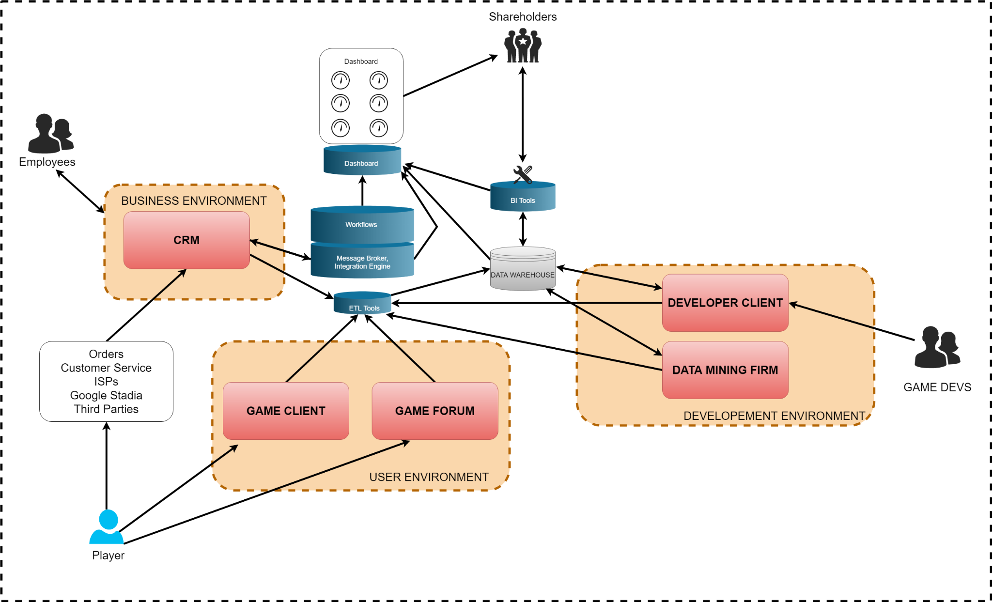

Figure 15: IT Architecture of SU Interactive

**Business Environment**

* CRM：A customer relationship management system is used by the organisation to administer its interactions with customers, store their data and track customer interactions and share this information with colleagues e.g. other employees within the organisation.
* These business processes are recorded to the CRM such as Orders, Customer services, ISPs, Google Stadia and Third Parties.

**User Environment**

It manages the organisations’ user experiences within their control environment such as:

* Game Client
* Game Forum

**Development Environment**

This is a collection of processes and tools that are used to develop the source code for a program or software product. The involvement of the entire environment that supports the process end to end, is not limited to Developer Client and Data Mining Firm, development, staging and production.

**Data Layer (Systems)**

* Dashboard
* Workflow
* Message Broker enables applications and communications between on-premises systems and cloud components in hybrid cloud environments. Using the service will increase control over interservice communications and ensure the security of data.
* Interactive Engine
* ETL Tools means to extract, transform and load the data, which is extracted from data sources and transformed into a proper format to further store and purposes of referencing.

**Data Layer (Data access)**

* BI Tools : it is an application software where collects and processes amounts of unstructured data from internal and external systems.
* Data Warehouse is an enterprise data warehouse which is a system used for reporting and data analysis. It plays an important part in the business intelligence unit. DWs are central repositories of integrated data from one or several disparate sources.

# 6 Business Performance Management

This section introduces the key performance indicators (KPIs) for measuring and analysing the business processes of SU Interactive.

## 6.1 Leading and Lagging KPIs

The tables below include five leading KPIs and five lagging KPIs. The tables consist of the name of the KPI, the definition of the KPI, which goal in the SU Interactive’s goal model the KPI is related to, target values (only for the lagging KPIs), which part of a business process, i.e., which activity the KPI measures, which IT system that will be the data source for the KPI, and which type of IT solution will feed the dashboard system with data from the source system.

The bullet points below describes the relationship between the chosen KPIs for SU Interactive:

* “Number of new patches for the game” influences “Don’t lose a current player”.
* “Number of sales meetings with retail stores” influences “Increase the amount of retail stores that sell the game”.
* “Number of offers and discounts” influences “Sales from Google Stadia”.
* “Number of item bundles” influences “Increase in-game sales”.
* “Number of promotions and adverts” influences “Number of players”.

| Leading KPIs | | | | | |
| --- | --- | --- | --- | --- | --- |
| Name | Definition | Goal | Business Process | IT System | IT Solution |
| Number of new patches for the game | Describes the number of updates SU Interactive executes | Keep current players | Game development, player feedback, regular game events | Data Warehouse | BI Tools |
| Number of sales meetings with retail stores | Describes the number of sales meetings SU Interactive conducts | Increase amount of retail stores that sell the game | Assortment management, provision of the process of choosing and merchandise payment in a salesroom, financial management, human resource management, safety and security arrangements | Data Warehouse, Inventory Management Software, CRM, Accounting Information System | BI Tools |
| Number of offers and discounts | Describes the number of offers and discounts offered through Google Stadia | Increase sales from Google Stadia store | Promotional campaigns | CRM, Inventory Management System | BI Tools |
| Number of item bundles | Describes the number item bundles being sold in-game | In-game sales shall increase | Sales and marketing, game development | CRM, Data Warehouse | BI Tools |
| Number of promotions and adverts | Describes the number of promotions and adverts conducted | Increase the number of people playing the game | Sales and marketing,  game development, feedback loops | CRM, Data Warehouse | BI Tools |

Table 2: Leading KPIs

| Lagging KPIs | | | | | | |
| --- | --- | --- | --- | --- | --- | --- |
| Name | Definition | Goal | Target values | Business Process | IT System | IT Solution |
| Don’t lose current players | Describes the number of players who stop playing the game | Keep current players | Don’t lose more than 5% of current players in 2021 | Game development, player feedback,  regular game events | Data warehouse | BI Tools |
| Sell in more retail stores | Describes the number of retail stores that are currently carrying the game in their assortment | Increase amount of retail stores that sell the game | Have the game on the shelves of at least 10% of the retail stores in Sweden in 2021 | Assortment management, provision of the process of choosing and merchandise payment in a salesroom, financial management, human resource management, safety and security arrangements | Data warehousing, Inventory management software, CRM, accounting information systems. | BI tools |
| Google Stadia sales | Describes the growth in revenue that has been made through the sales of Google Stadia via promotions, campaigns. As well as the number of sales and cost of each sold item | Increase sales from Google Stadia store | At least 10% increase in 2021 compared to the previous year | Promotion campaigns | CRM, Inventory Management System | BI tools |
| In-game sales | Describes the number of total sales that have been made in-game | In-game sales shall increase | Increase in-game sales by 15% by the end of 2021 | Sales and marketing, game development | CRM, Data Warehouse | BI Tools |
| Number of players | Describes the number of players that are playing the game and/or subscribe to the game | Increase the number of people playing the game | Increase the player base by at least 10% by the end of 2021 | Customer service,  sales and marketing,  feedback loops, game development | CRM, Data Warehouse | BI Tools |

Table 3: Lagging KPIs

## 6.2 Evaluation of KPIs

The purpose of the KPIs is to guide the development of SU Interactive and the game. Eckerson[2] states that KPIs are like levers that executives can pull to move the organization in the desired direction. The KPIs for SU Interactive have been developed to help guide the company towards the stated goals in the goal diagram (figure2). The foundation of any game is to keep its active player base, thus our first KPI measures the number of players who stop playing our game to help monitor and manage player loss. The second and third KPIs measure the number of retail stores that carry the game and sales from Google Stadia respectively, this will assist with gaining market share. The player growth will be measured with the fifth KPI. Lasty the fourth KPI monitors in-game sales as this will be a key income source for the company.

# 7 Enterprise Architecture Evaluation

Capability Elicitation

| **Concept** | **Description** |
| --- | --- |
| Capability | * Sales of in-game equipment |
| Goal | * Increase the in-game sales |
| KPI | * The number of players who purchased in-game gears * % of growth in sales revenue |
| Context | * Daily in-game equipment sales range * Holiday season in-game gear sales range |
| Process | * In-game equipment order process * The payment process * Delivery and shipment process of in-game equipment * The third-party in-game sales process |
| Process Variants | * The third-party in-game purchase order * SU Interactive in-game purchase order |

Table 4: The Capability Elicitation of In-game Gear Sales of SU Interactive

Table 4 presents the necessary components which are required for capability elicitation. The paper decides to focus on one of the capacities of the SUN Interactive, i.e., the ability to sell in-game equipment to the players. This precise capability is tied to one core subgoal namely, ‘increase the in-game sales’. This goal is directly connected to the SU Interactive’s main overarching goal, which is the overall increase of revenue. The table also includes two KPIs which can be used to measure the performance of the concerned goal. The capability of selling in-game gears tried to two possible contexts. One of the contexts is ‘daily’ in-game sales range that focuses on the daily estimated sales; whereas, the other context involves sales in the holiday season. These contexts will be useful to know how SU Interactive’s capability of selling products in certain situations. Moreover, there are four processes that are connected to this capability. The first process is the ordering process which intels how the players should be able to submit purchase orders. Subsequently, the second process involves the payment process for the particular order. Finally, the penultimate process is about the shipment of the in-game gears to the actual customer (the player). The last included process is about how SU Interactive will get its percentage of sales from the third-parties when they sell in-game gears to players.

Since, the discussed capability has four processes involved to it, the paper only focuses on the initial process, i.e., ordering process, thus we have two variants of that process namely purchase order from SU Interactive directly or purchase order via the third-party.

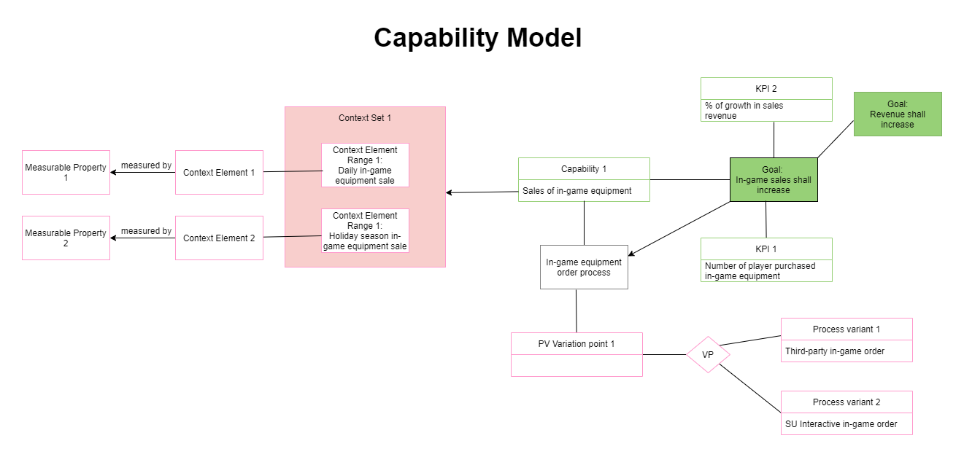

Figure 16: In-game Equipment Sales Capability Model of SU Interactive

The newly designed in-game equipment sales capability can be observed in figure 16. The capability model has three parts. The first part is the enterprise modeling (top right side), which is essentially the portion of the global model of SU Interactive that is connected to this capability. This part also includes the KPIs. The second part is the context modeling (top left side). Finally, the business process and its variants are shown in the bottom right side of the diagram.

REFERENCE   
[1] <https://en.wikipedia.org/wiki/Massively_multiplayer_online_role-playing_game>

[2]Eckerson, how to create effective metrics <https://drive.google.com/file/d/192lQdOApMim-0L7saa5lAjj9gWOAq3QO/view>